Course Title: Social Immersive Learning
Course Code: 24UC0021
Name: L.Ishitha
Roll No: 2420030041
Section: 10

Title of the Topic:
How to Build and Scale a Startup

Introduction:
How to Build and Scale a Startup is an insightful and empowering event designed for aspiring entrepreneurs who aim to convert their innovative ideas into successful and sustainable businesses. The session focuses on the essential stages of startup development — from idea validation, product development, and team building to marketing strategies, funding, and scaling operations.
The event emphasizes the importance of an entrepreneurial mindset—creativity, risk-taking, problem-solving, and adaptability. It also highlights how startups play a crucial role in driving economic growth, technological innovation, and social impact. By attending this event, participants gain a clear understanding of what it takes to transform a simple idea into a thriving venture.

About the Event:
This event provides a comprehensive roadmap for aspiring founders to navigate the startup journey effectively. Participants are introduced to the key phases of startup development, including:
- Ideation & Market Research: Understanding customer needs, identifying market gaps, and validating the idea before product creation.
- Building a Minimum Viable Product (MVP): Developing a basic, testable version of the product to attract early adopters and gather user feedback.
- Funding & Investor Relations: Exploring various funding options such as bootstrapping, angel investment, venture capital, and crowdfunding.
- Marketing & Growth Strategies: Learning about branding, customer acquisition, and digital marketing techniques that help scale the business.
- Sustainability & Scaling Up: Expanding the startup while maintaining efficiency, culture, and customer satisfaction.
The event includes expert talks, interactive workshops, and networking sessions, offering real-world insights from successful entrepreneurs and startup mentors. Attendees also gain exposure to modern trends such as AI-driven business solutions, automation, and global scaling strategies, which are essential for startups in today’s digital era.

Key Learnings:
- Understanding the complete startup lifecycle — from concept to scaling.
- Importance of innovation, adaptability, and problem-solving in entrepreneurship.
- Insights into fundraising methods and investor engagement.
- Knowledge of digital marketing and AI integration in modern businesses.
- Building a sustainable and scalable business model with long-term vision.

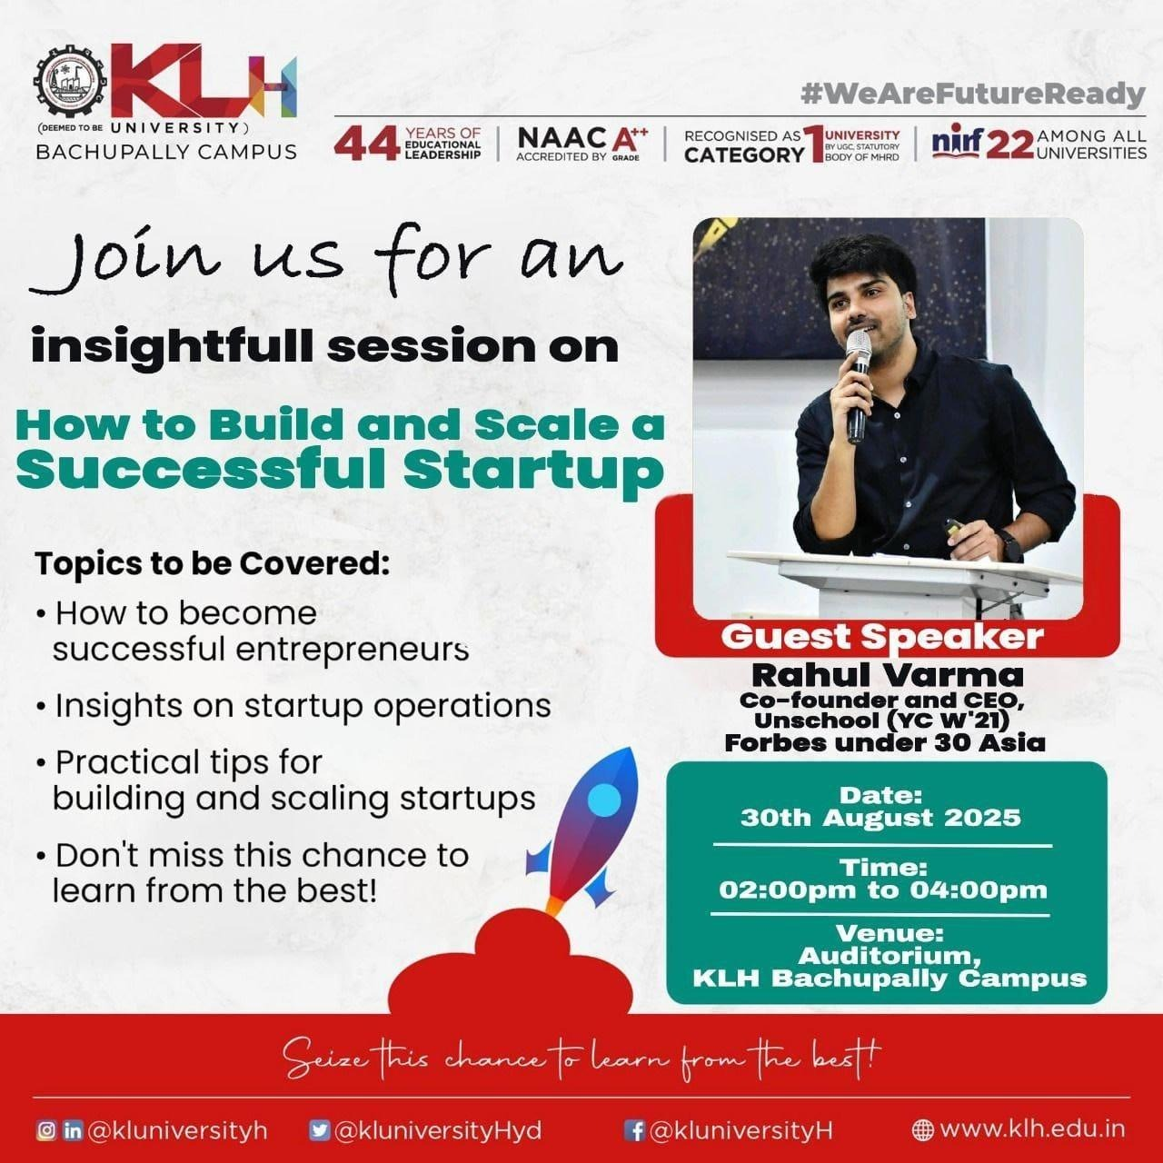
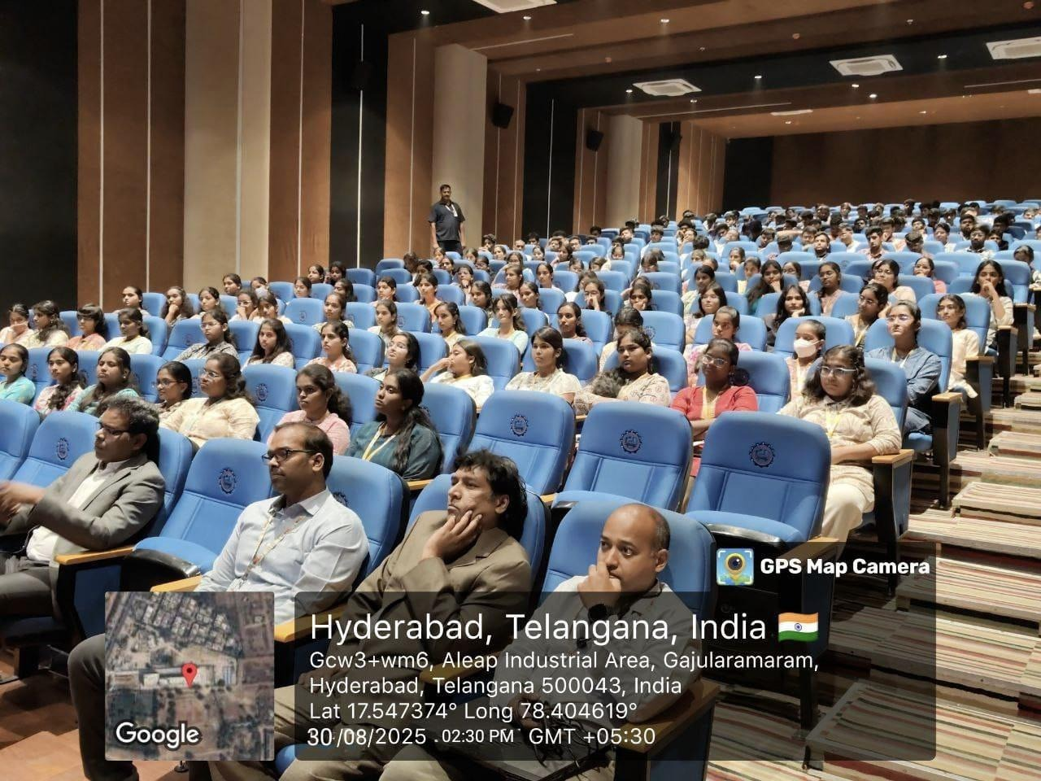
Conclusion:
The session on How to Build and Scale a Startup provided an inspiring and practical perspective on entrepreneurship. It helped participants recognize that building a startup is not just about having a great idea but also about execution, perseverance, and continuous learning. The event encouraged young innovators to dream big, start small, and scale smart—paving the way for the next generation of impactful entrepreneurs.

